**MINT DOOR LAUNDRY SERVICE**

Mint Door is a hygienic laundry service with speed service at affordable price. The organization is handling more than 50 orders per day. In order to develop the organization, the business has been implemented into salesforce. With the help of salesforce customer can easily opt for service.

**Salesforce**:

Salesforce is a cloud platform where can design and develop the business. It will help us to trade, service, marketplace, study and it will give you an entire view of a client and vision hooked on your individual business. The major importance of salesforce is, can run our business from wherever we want because salesforce has the whole thing which we required. With normal goods and features, you can manage the relationship with our business partners and clients and easily can cooperate and engage with our workers in single place. The entire data is stored firmly in the cloud.

Even salesforce allows you to modify and personalize the features, products, workers, clients and workers. So, you can easily extend our business outside out of the salesforce functionality. You can easily login into your salesforce through an internet connection or web browser without any installation of salesforce software.

The implementation of Mint Door laundry service in salesforce explained in an order as below,

1. Architecture
2. Process control features
3. Integration and user interfaces
4. Reports and Dashboards
5. Approach to build dataset
6. Steps taken to build system
7. How system is used
8. Business benefits

**Architecture**:

I have developed Mint Door laundry service organization using salesforce interface. I have created an application in my salesforce account and I have created multiple tabs as per my business requirement. My application screenshot showed as below,

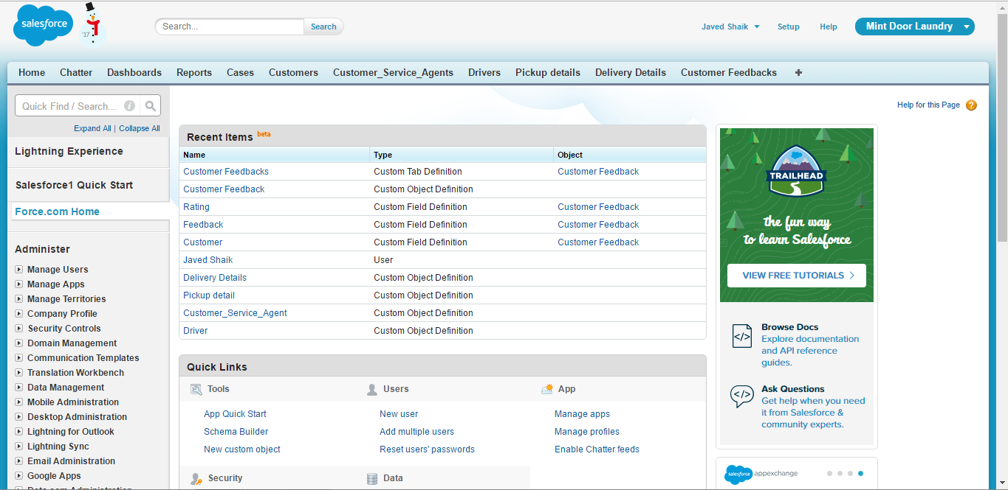

The highlighted fields are application and tabs in salesforce.

*Customers tab*: In this tab which contains all information about the Mint Door laundry service customer details includes customer name, gender, email, phone number, and address.

*Customer service agent tab*: In this tab which contains details about the Mint Door laundry service employees. It holds the employee name, email, phone number, and address.

*Driver tab*: In this tab which contains the details about the Mint Door laundry service driver details which includes the driver name, email, contact number, and address.

*Pickup details tab*: In this tab which contains the customer clothes pickup details which include the customer ID, Driver ID, clothes pickup details.

*Delivery details*: In this tab which includes the customer clothes delivery details which include the unique ID’s of customer and driver and also clothes delivery details of the each customer.

*Customer feedback*: in this tab which contains the feedback details of customers. It includes customer ID, feedback comment, and customer rating.

**Process control Feature**:

The whole concept of the Door Mint laundry service is to receive the requests from the customers through the web case. One the customer submit their request in the web case, it will create a request in the form of a new case in cases tab and a default email will go the customer stating that customer service agent is looking into it. Once the case created, the customer service agent will look into the case and allots the driver to pick up/deliver the clothes of the customer as per the customer request. The whole process between the new cases to completed case has been saved in the form of activities in several intervals. The below screenshot shows the schema of the Door Mint laundry service process.

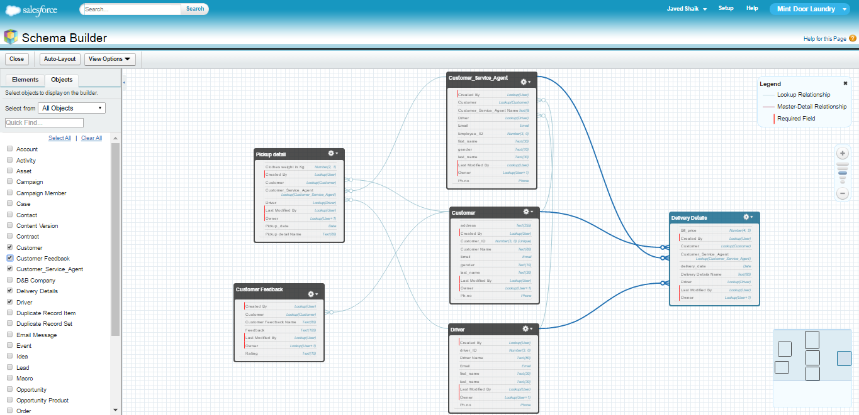

The relations between the tabs has given with the help of lookups. The lookup can be given with the help of unique keys of each tab.

**Integration and user interface**:

With the help of “the web to case” option, I have created a web page in which customers can easily submit their queries. Once customer submits their query in web form, it will create a new case in salesforce and also default email will be delivered to the customer. And the customer service agent can easily do their job as per the customer requirement. The web form has been shown as below,

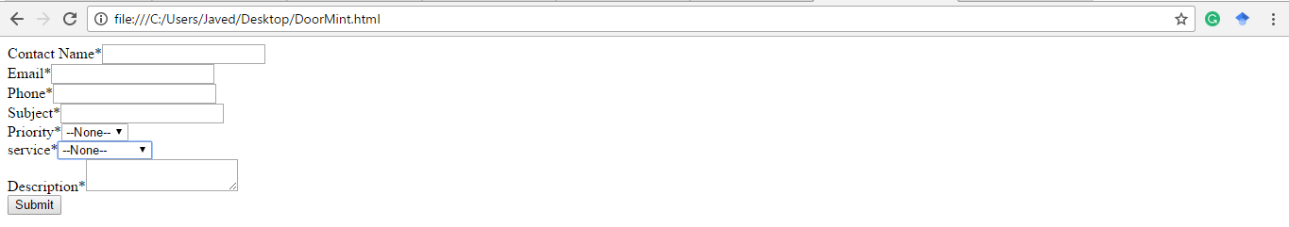

This web form is generated through the web to case HTML generator and I have modified with few changes as per my requirement. The highlighted box shows my salesforce account unique key.

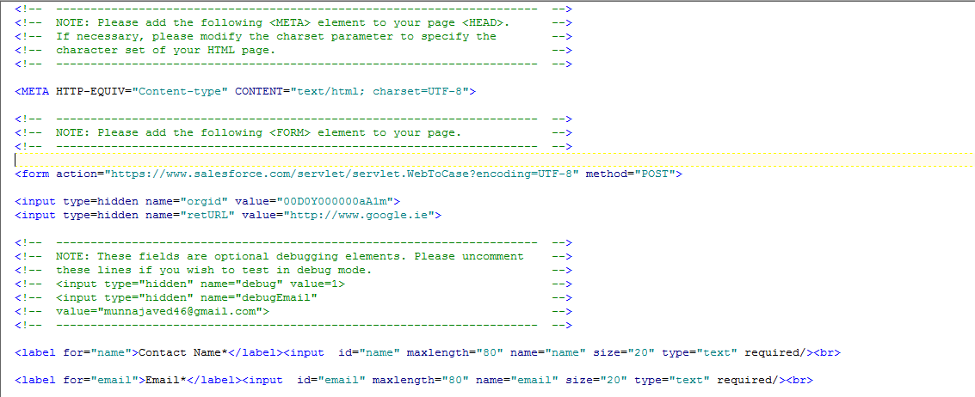

The user will fill the web form as shown below and once give submit, it will create a new case in sales form in cases tab and a default email has been forwarded to the customer through the salesforce.

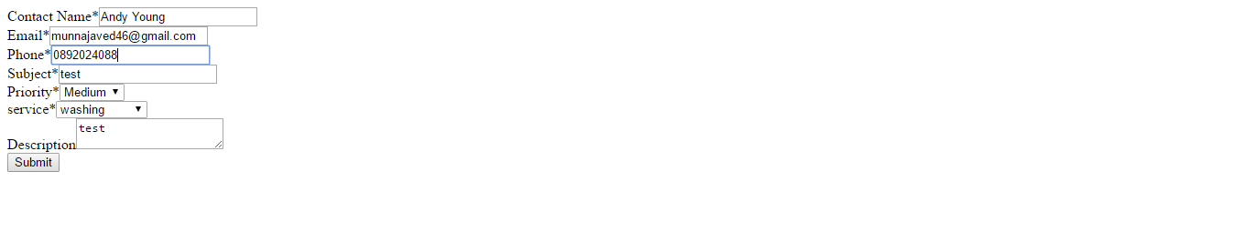

Below screenshot showing the cases tab, in which new case has been created as shown in the highlighted box.

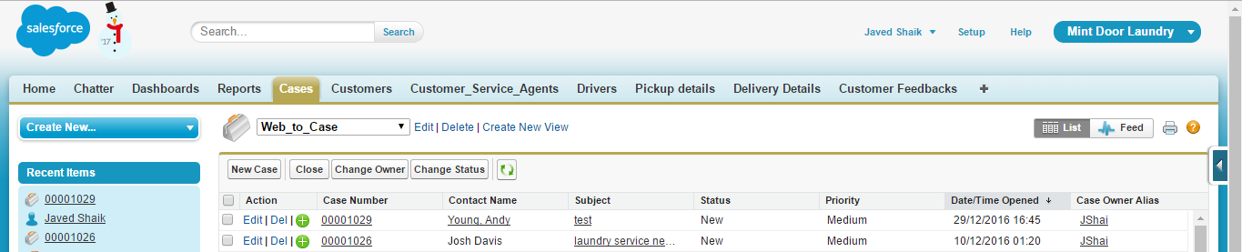

The case details as shown in the below screenshot,

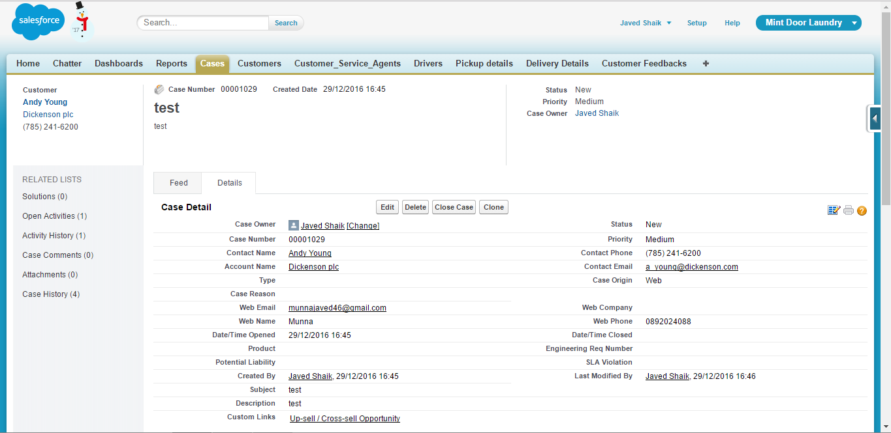

Whenever customer service agent is doing a task, it will add into the tasks column as shown below,

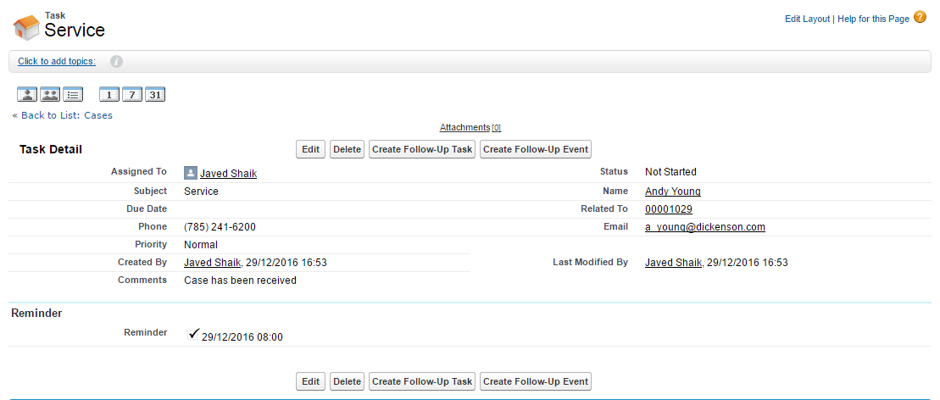

Once the case has been received, customer service agent changes the status into in Progress which includes the allotting the driver, pickup and drop clothes details. Till the clothes are delivered successfully the status remains in In Progress. The screenshot of the task as shown below,

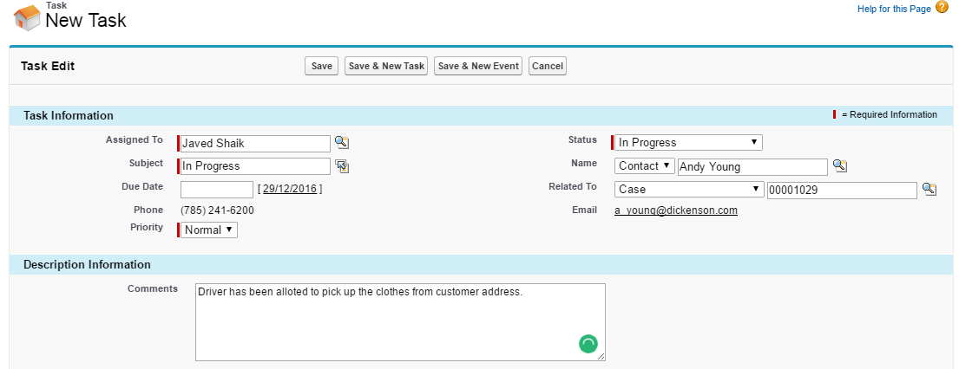

Once the clothes are delivered successfully to the customer, the customer service agent will change the state of the case to completed as shown in the below screenshot.

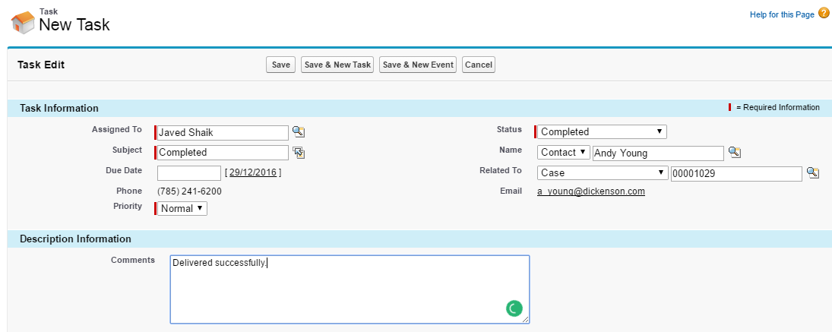

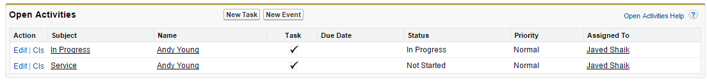

**Reports** **and Dashboards**:

Using reports can easily analyze the data of the organization to make high profits. Below screen shot shows the reports of Door Mint Yearly reports.

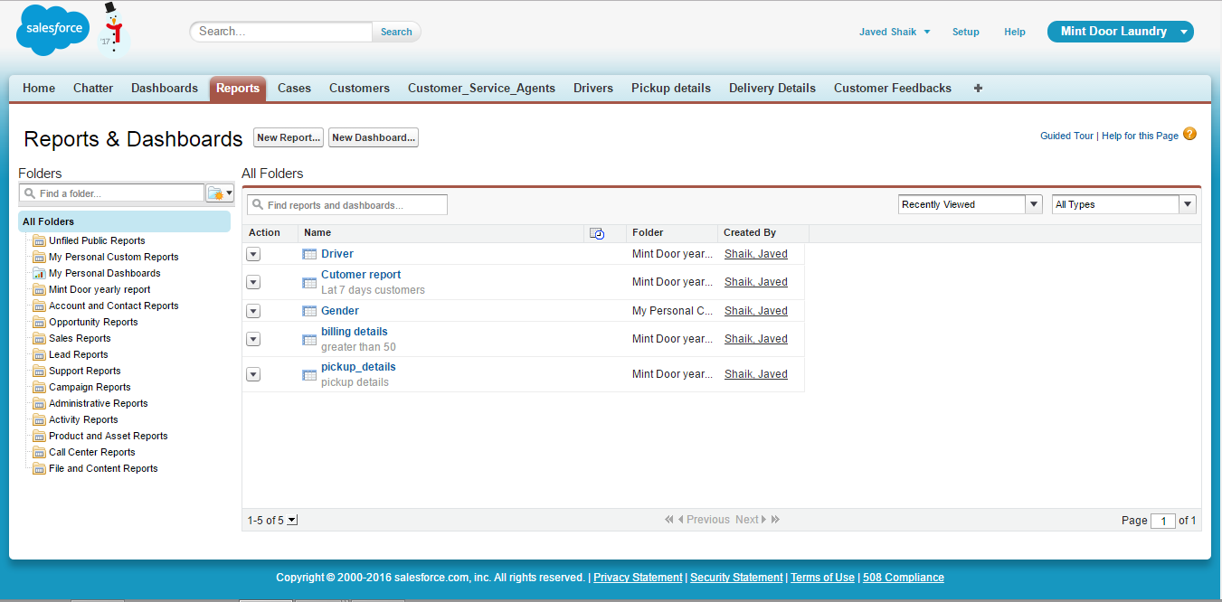

Pickup details report

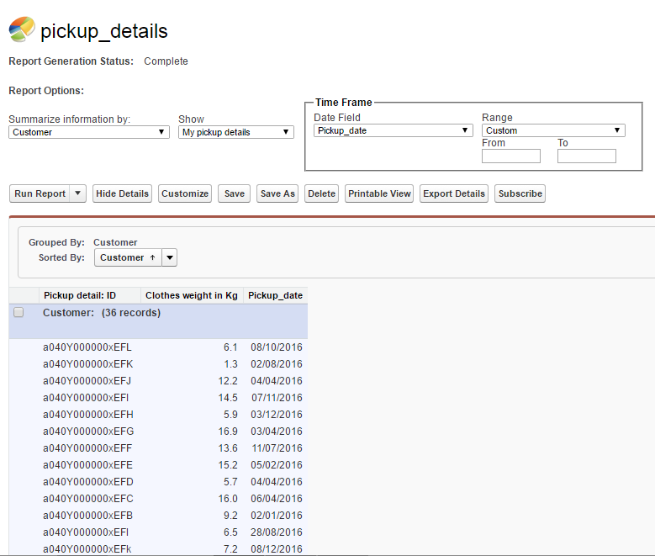

Driver report

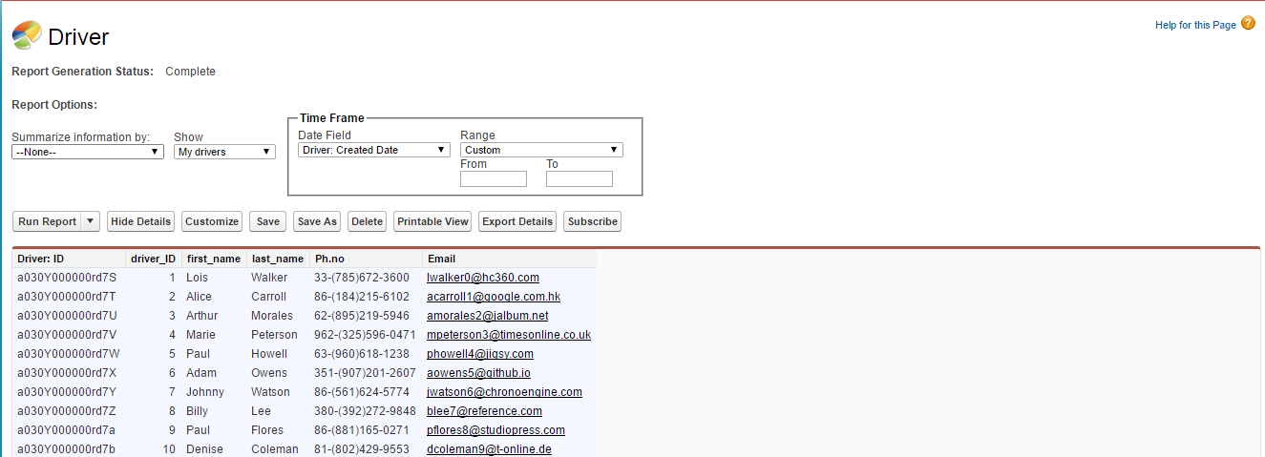

Below screenshot shows the billing details which are above 50,

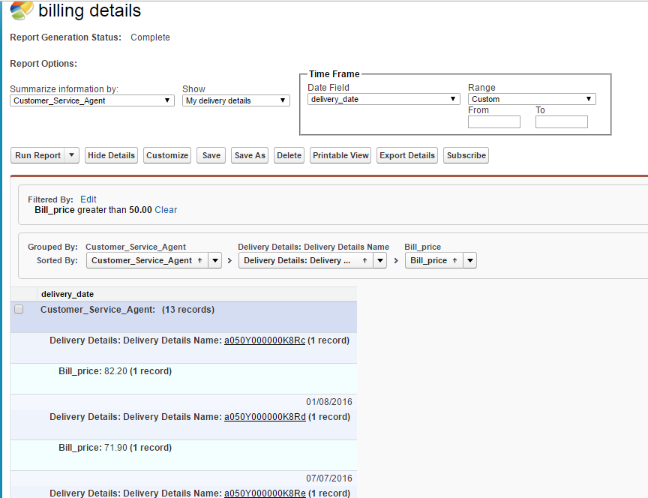

Customer rating dashboard

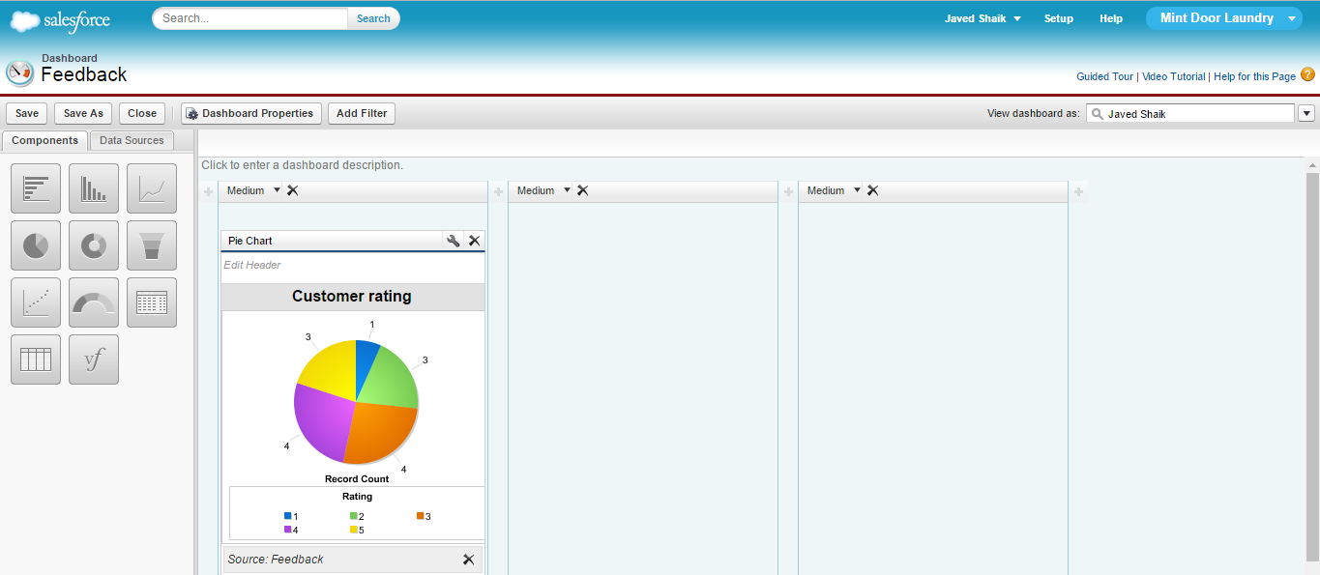

Billing details dashboard

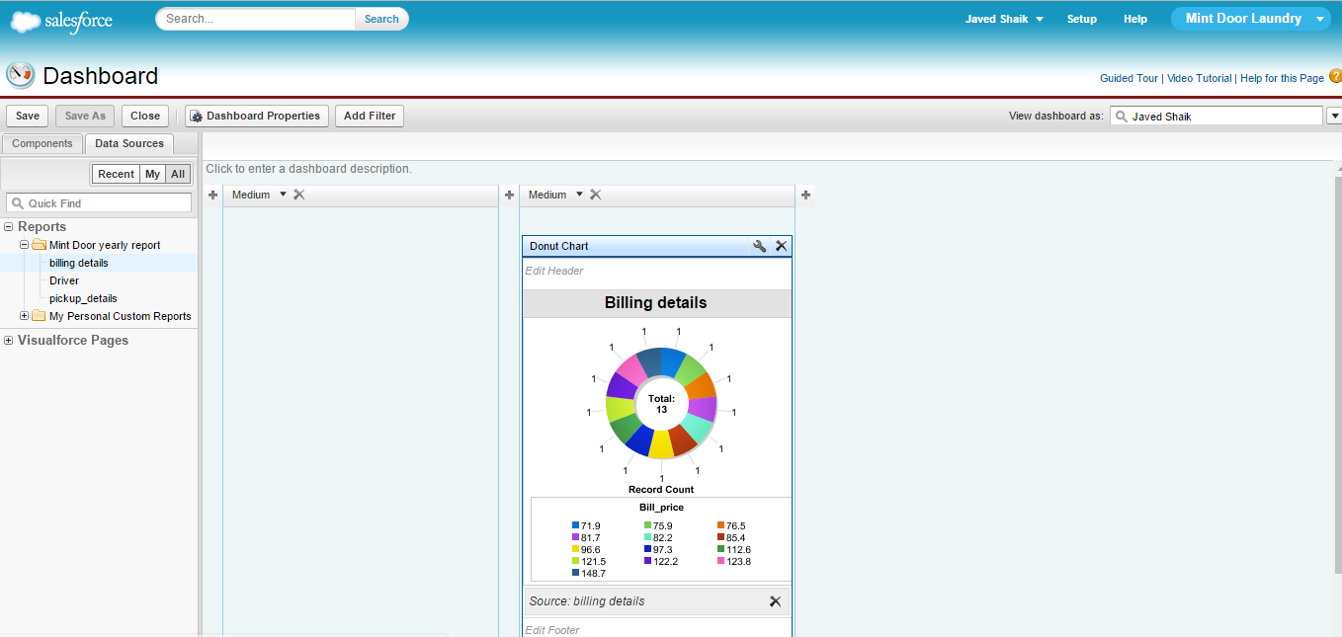

**Approach to build dataset**:

To load the data into the objects, I have downloaded the “Apex data loader” from the salesforce under the data management tab. To create the dataset I have used the website [www.mockroo.com](http://www.mockroo.com), through which I have created the datasets as per my field’s requirement. Using the Apex data loader I have loaded the datasets into the each object into the salesforce account.

**Steps taken to build system**:

Planned the salesforce design in the form the form of objects and fields. And I have given the relations between the objects through the unique fields. To view the Objects in the salesforce, go to Setup and under the Build option click on Create, under the Create tab, click on Objects. Below screenshot shows the custom objects created in the sales force under the Mint Door application.

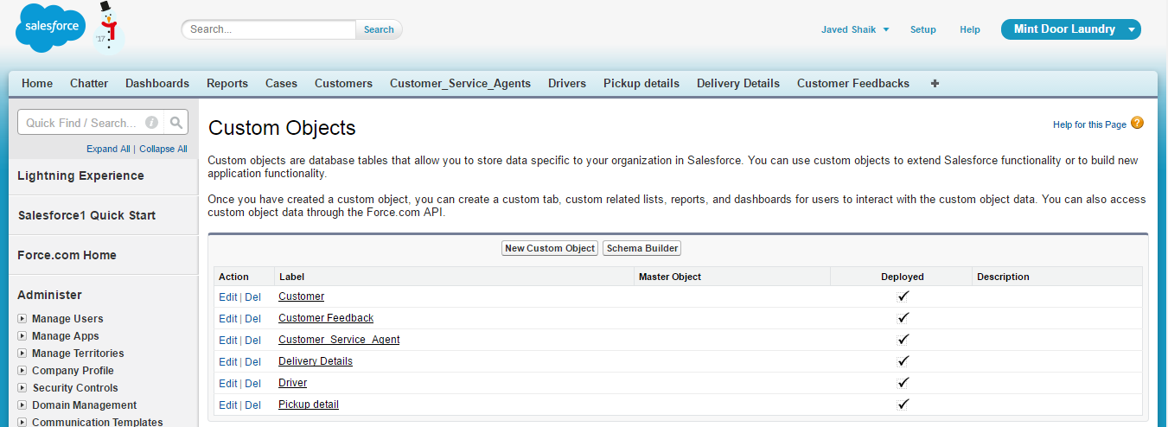

After created the custom objects, the objects has been shown as tabs using Tab tool under the Create option. Each tab represent with unique image (Tab Style) as shown below. Once create tabs, it shows as shown in the highlighted box.

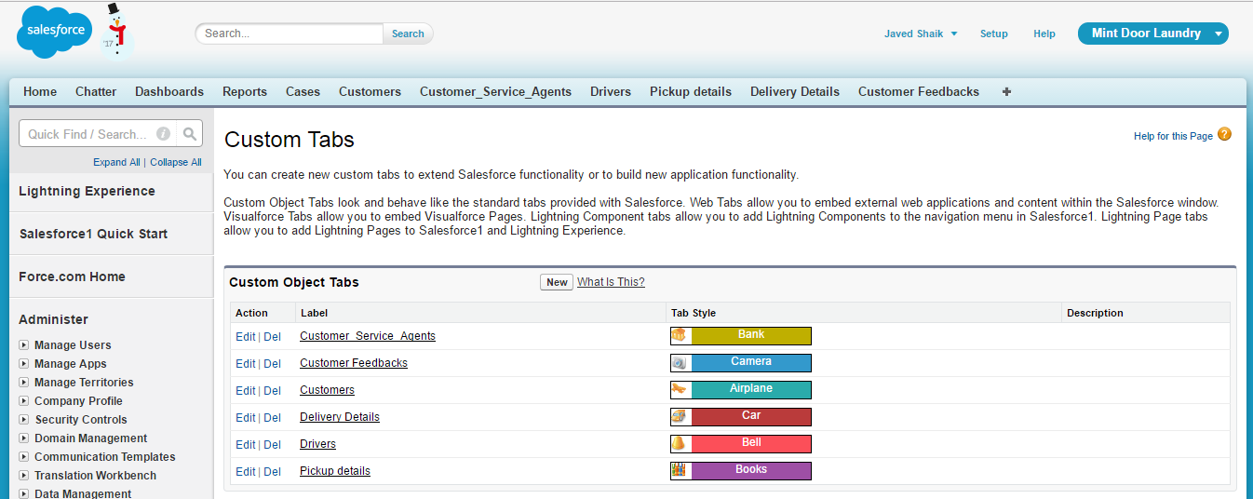

In each Object, there are several fields as shown below,

Customer tab fields

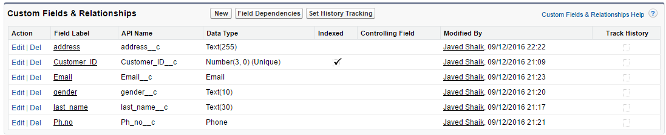

Customer service agent tab fields

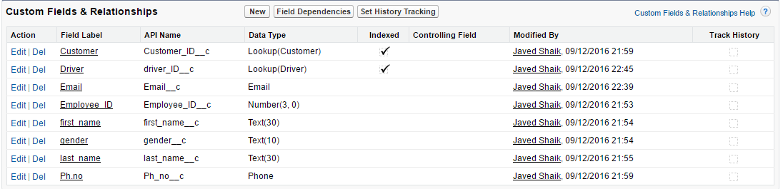

Driver tab fields

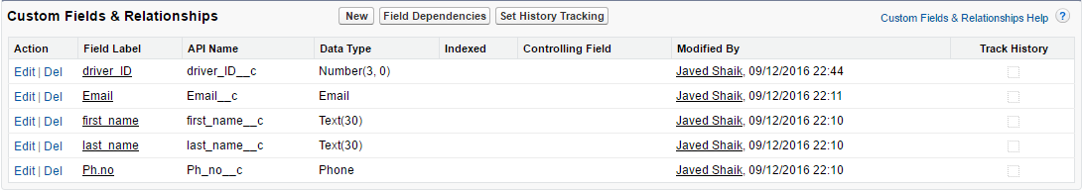

Pickup details tab fields

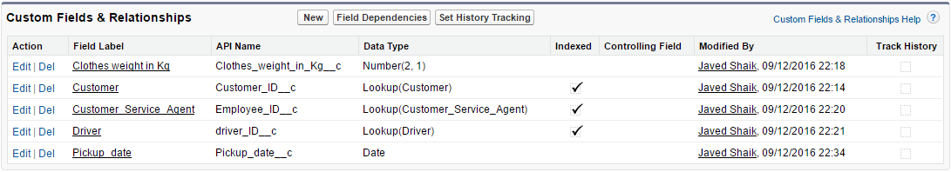

Delivery details tab fields

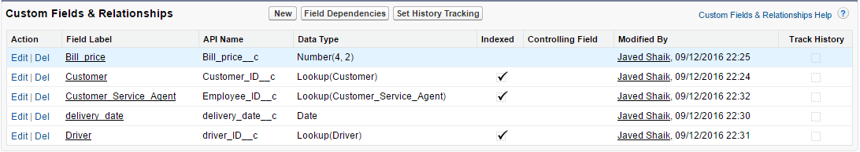

Customer feedback tab fields

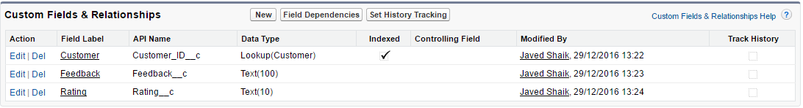

The relationship between the objects has been given using the lookup data type. Once the schema Builds, have to upload the datasets into the each object using the Apex data loader as shown below,

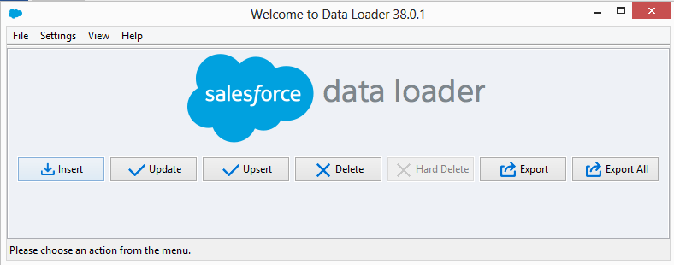

Below screenshots shows the data of the each object,

Customer tab data

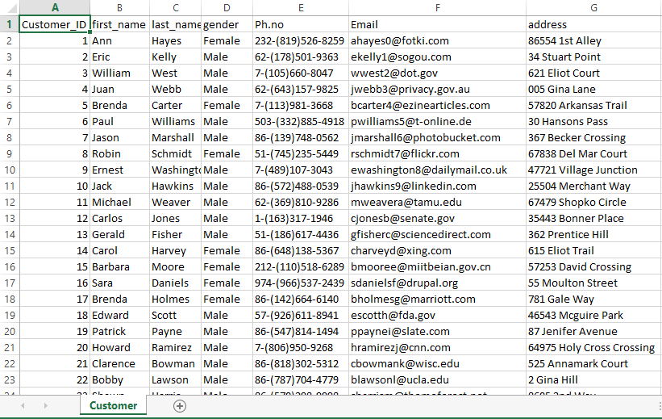

Customer data after loaded into the customer's tab

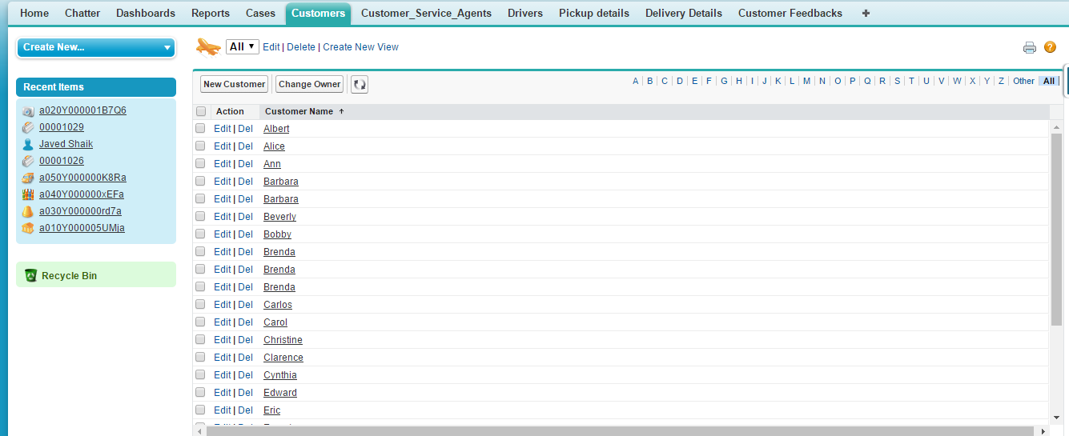

The below screenshot shows the customer detail of the particular customer,

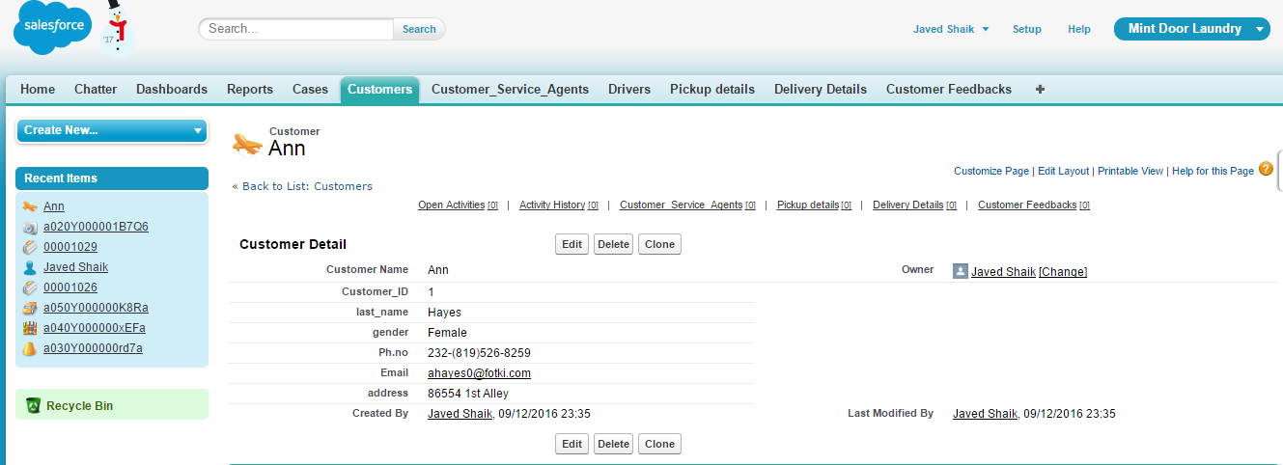

Driver dataset

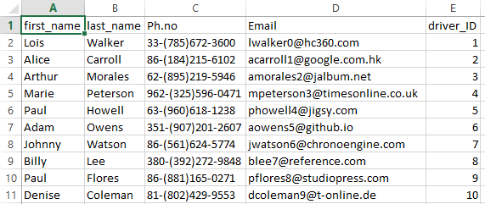

Driver data after loaded into the Drivers tab

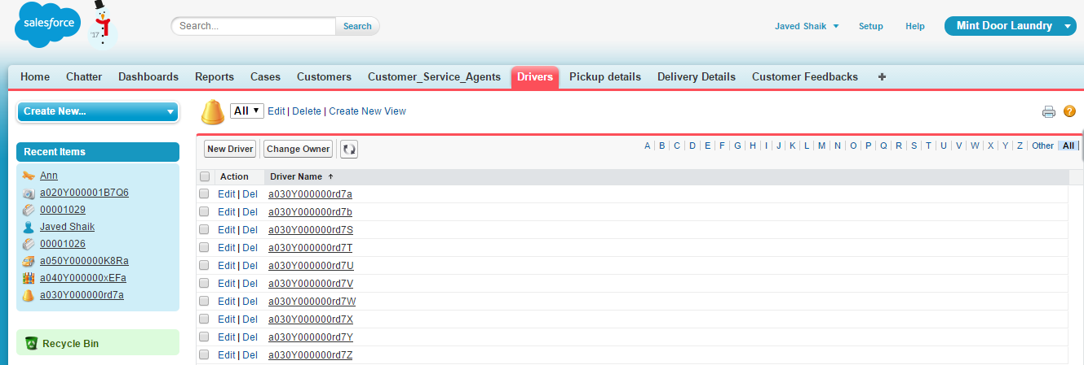

The below screenshot shows the Driver detail of the particular driver,

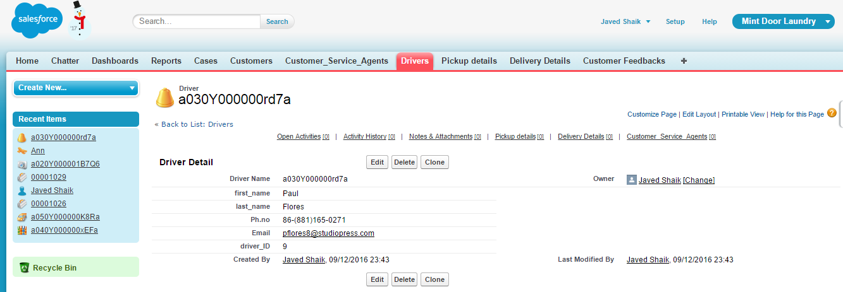

Customer service agent data

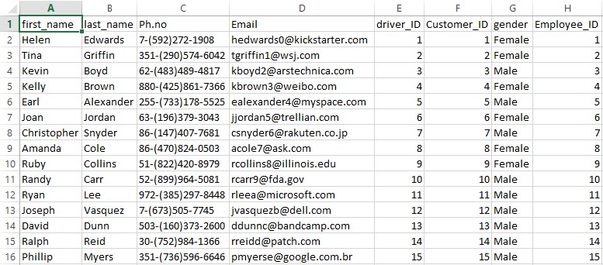

Customer service agent data after loaded into the customer service agents tab

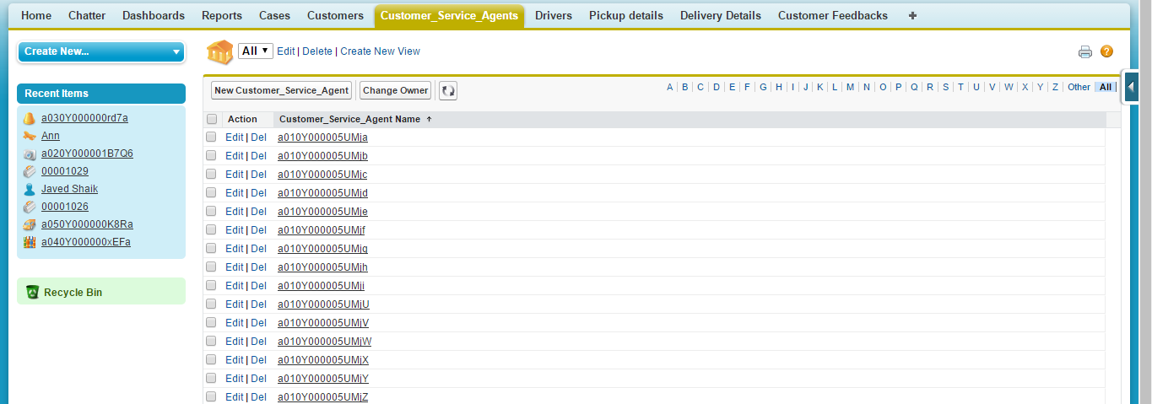

The below screenshot shows the customer service agent detail of the particular customer service agent,

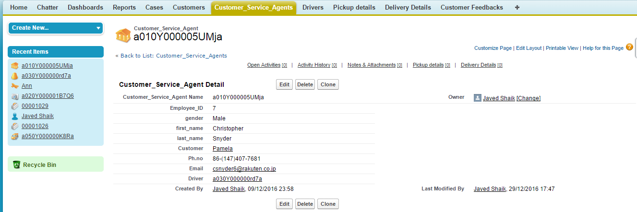

Pickup details data

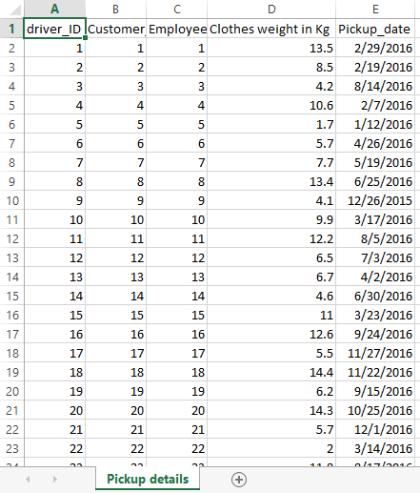

Pickup details after loaded into the pickup details tab

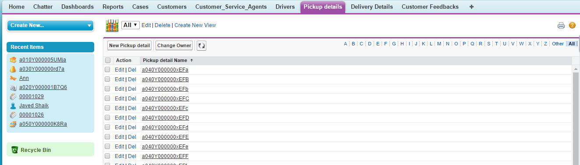

Below screenshot shows the pickup details of the particular pickup details

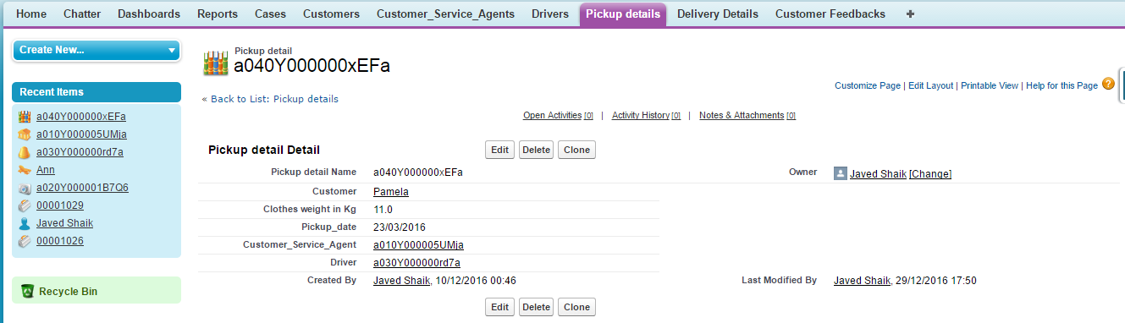

Delivery details data

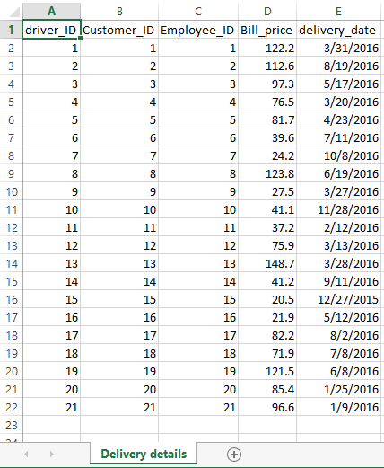

Delivery details after loaded into the Delivery Details tab

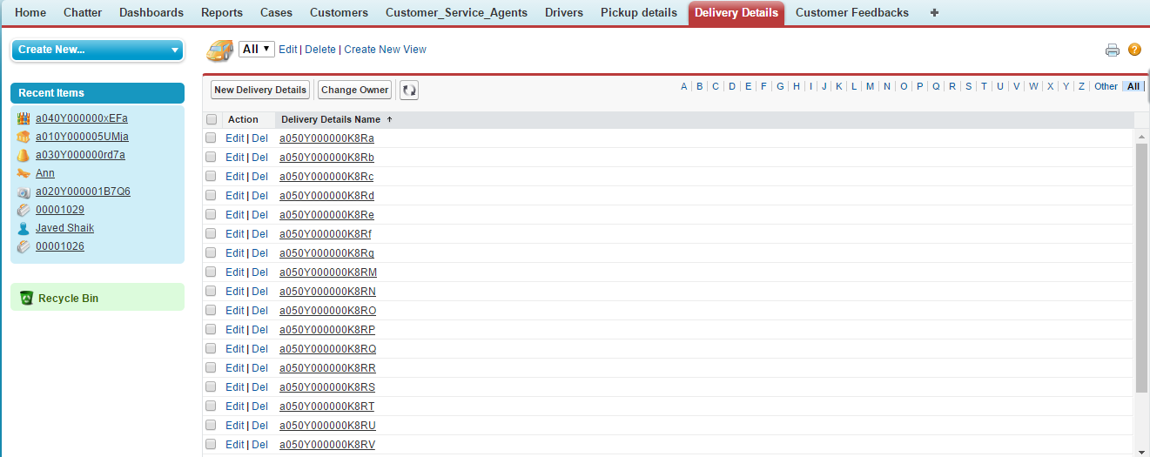

Below screenshot shows the delivery details tab detail for the particular Delivery Detail

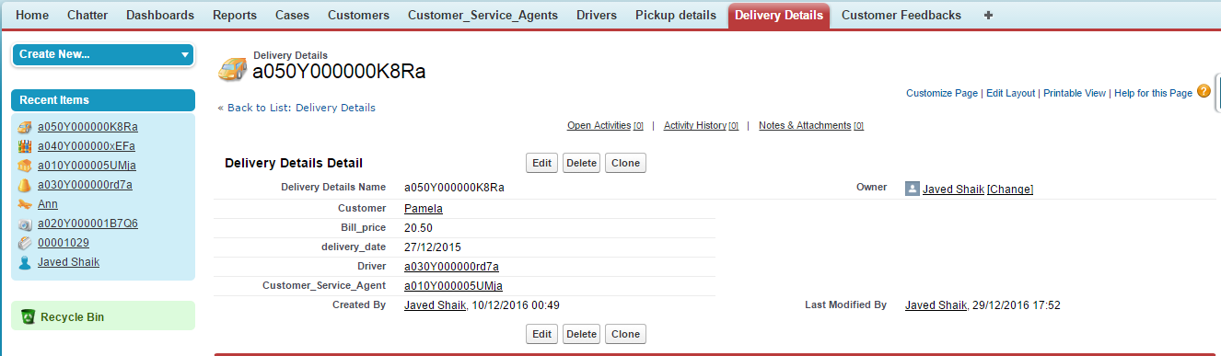

Customer feedback data

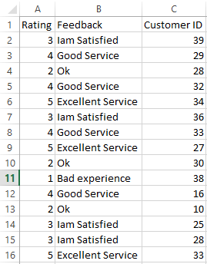

Customer feedback details after loaded the data into the Customer Feedbacks tab

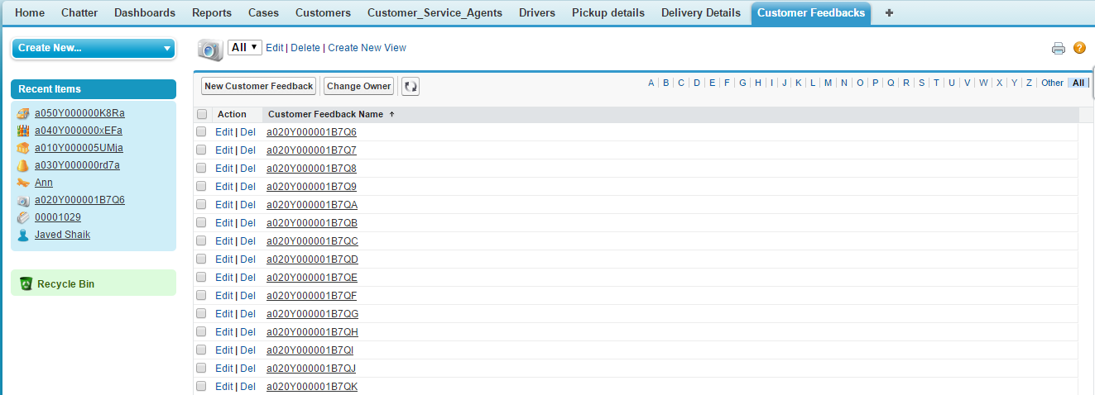

Details of the particular feedback

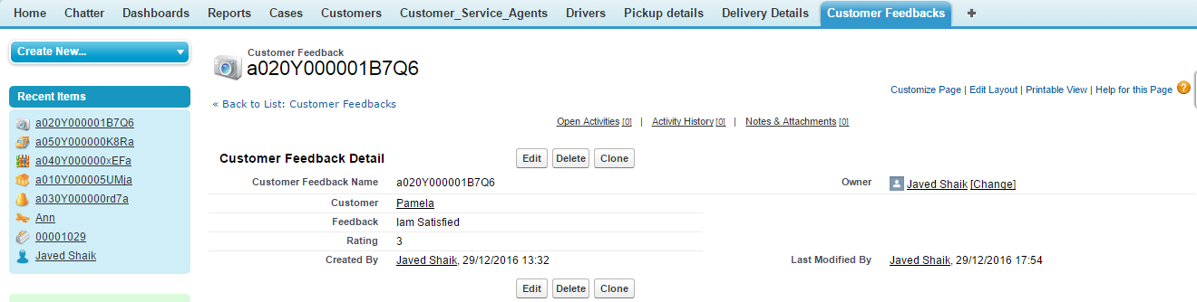

Cases tab

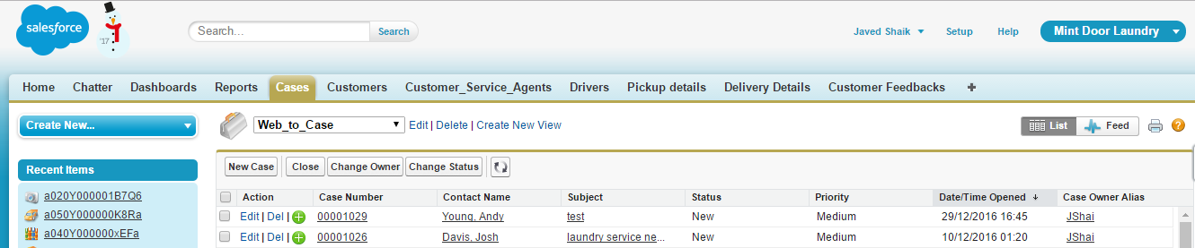

Case details as shown below

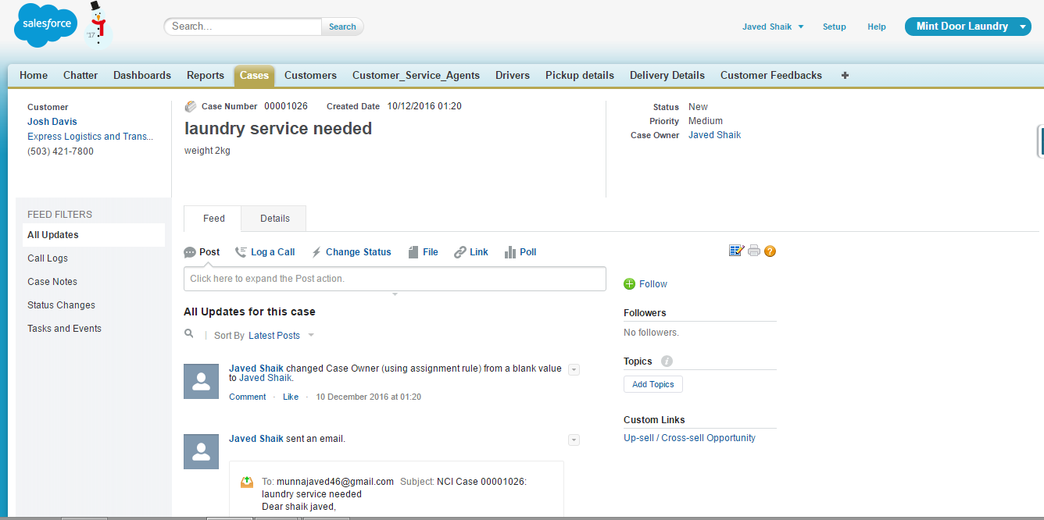

**How the system is used**:

* The salesforce system is used as a repository of all entire data which includes data’s of the customer, driver, customer service agents, pickup details, delivery details and customer feedbacks.
* Using this system, customers can easily opt for the service and makes the customer service agents to do the service as soon as possible.
* Can provide fast service by the organization using the sales force system.
* We can easily create reports and dashboards using the Reports and Dashboard options.
* Can easily notify the ongoing process to the customers using this the tasks.
* Using salesforce can store the lots of data in a structured format.

**Business Benefits**:

* Fast income may tops to business development more.
* Speed service.
* Updates of each task can be easily notified to the clients using the salesforce.
* User interface.
* Can easily handle the orders.
* Effortlessly handle the others like employees, customers, and drivers.
* The growth of the organization.